Streamlit visualization
- Revenue prediction using single model
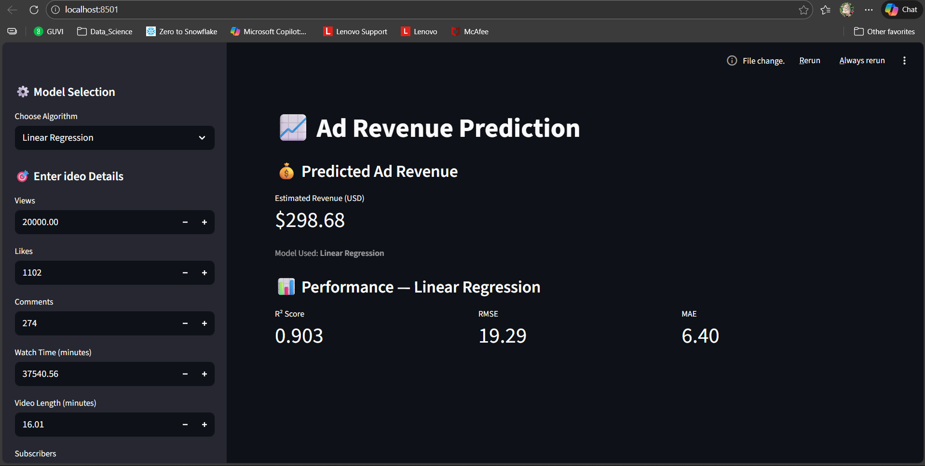

- Overall prediction summary

